Sub-task 1 – Create 3 User Groups

• CoordinatorsGroup

• MentorsGroup

• MenteesGroup

Sub-task 2 – Create policies and roles

1. Create a policy named FullAccessPolicyEC2.
2. Configure the FullAccessPolicyEC2 to allow any actions on the EC2 resources.

Similarly, create policies for S3:

* FullAccessPolicyS3 – everything’s allowed.
* ReadAccessPolicyS3 – only get and list actions.

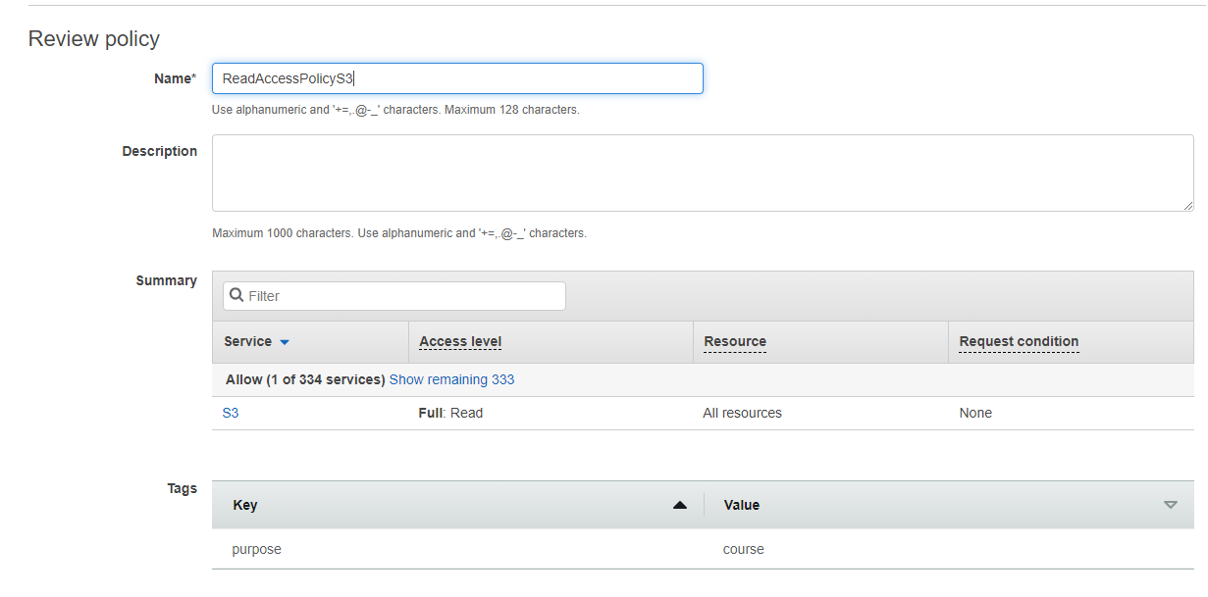

Create one role of EC2 Type (Trusted Entity) per each policy configured so far (note – these roles won’t be used right now, but might be reused in upcoming EC2 module):

* FullAccessRoleEC2
* FullAccessRoleS3
* ReadAccessRoleS3

Create one group per each policy configured so far:

* FullAccessGroupEC2
* FullAccessGroupS3
* ReadAccessGroupS3

Create 1 user from the 1st group, 1 user from the 2nd group, and 1 user from the 3rd group.

.

Configure named profiles for each user from the previous step to be used with AWS CLI in the subsequent modules.

In all cases you must not share your access keys. I share for course tasks and I will delete them immediately.

List profiles

\

Our first user does not have policy related to s3. So access denied

But second user can see s3

First user (profile) can describe instances

